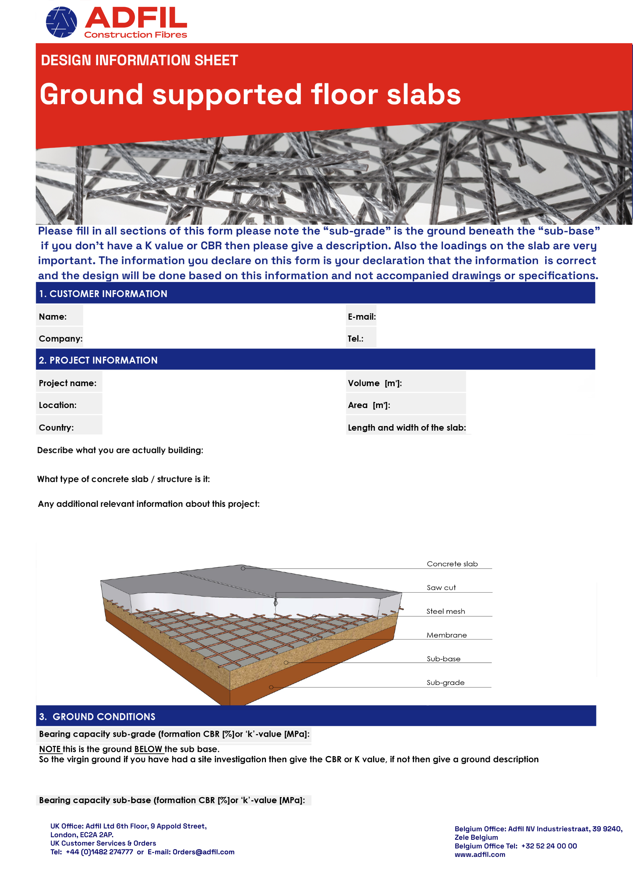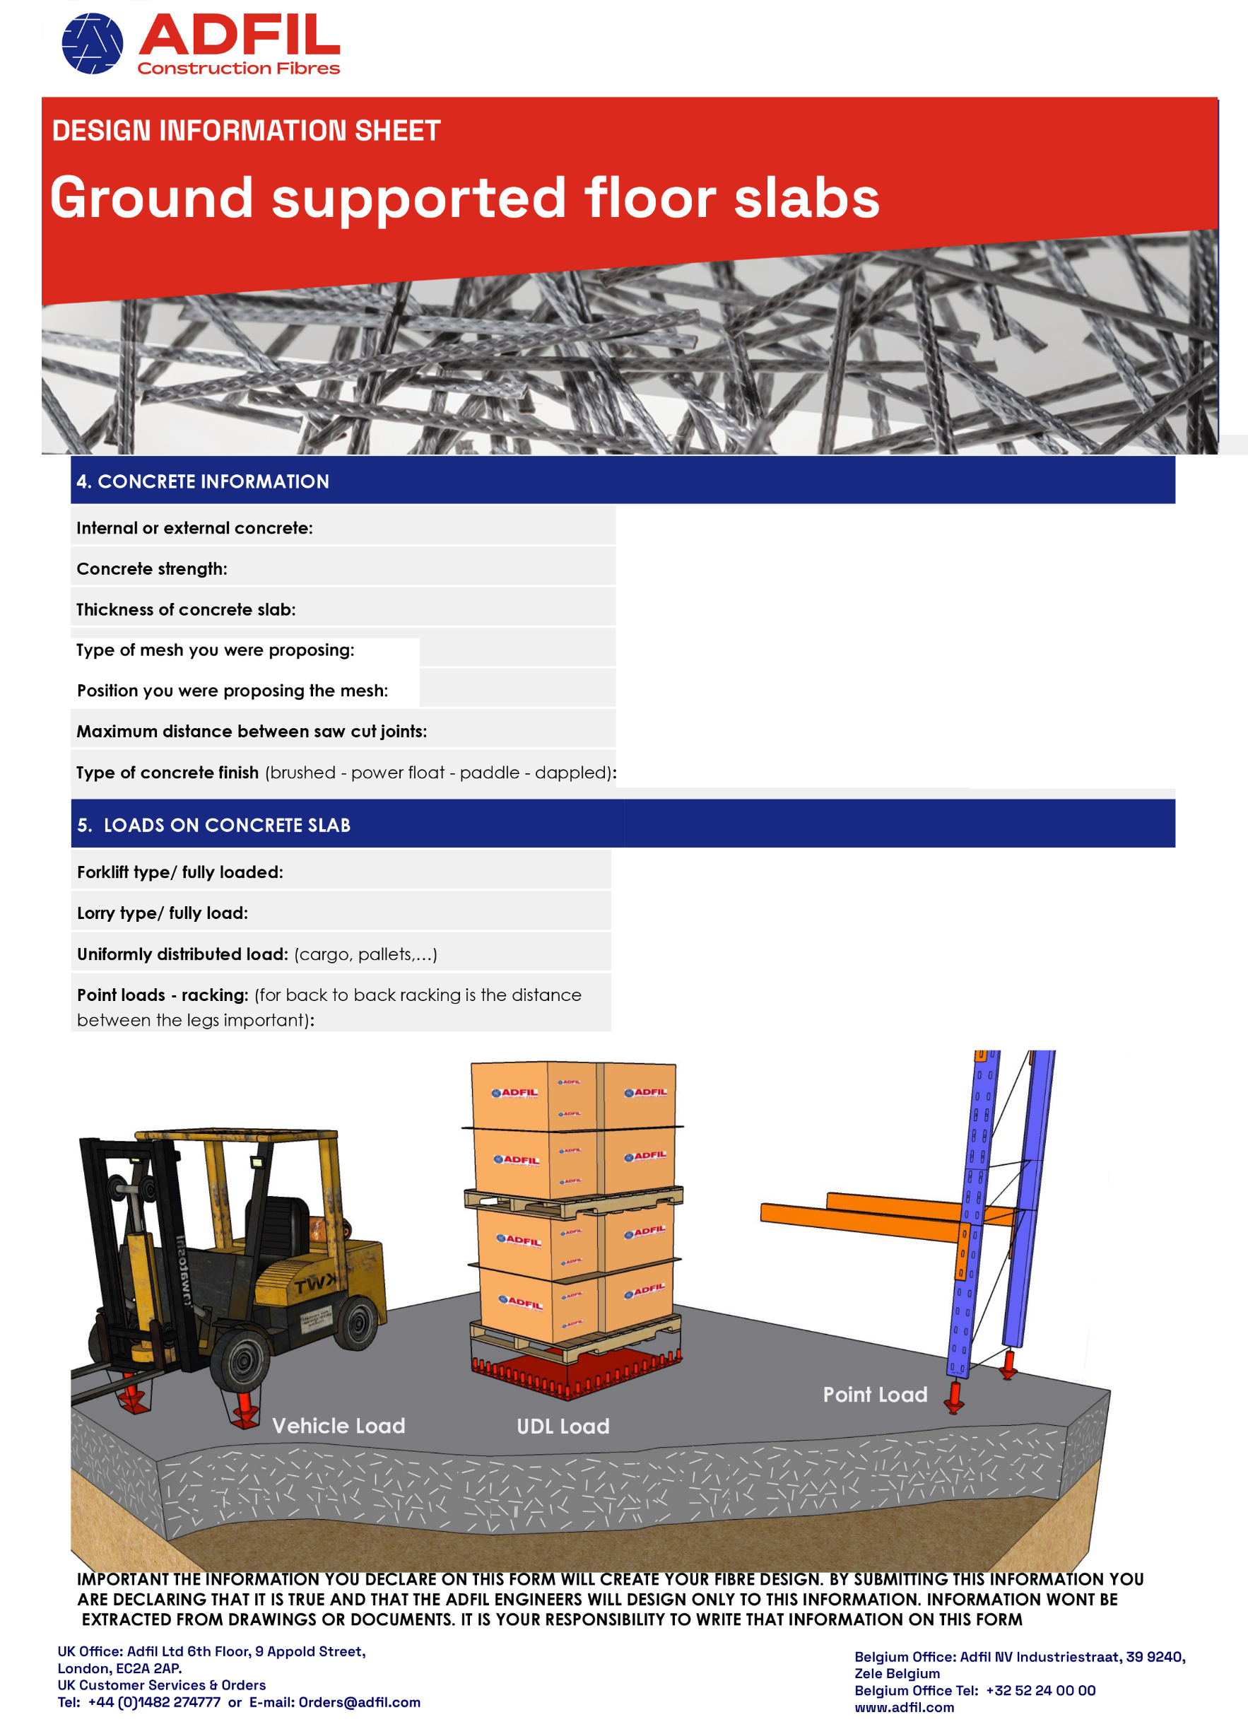

**C**

(kN or tonnes):

(kN or tonnes):

(kN or tonnes):

(kN/m2):

(m):

(mm) :